
5TH NORTHFLEET SCOUTS
KIPLING HALL
Rembrandt Drive
Northfleet
REG CHARITY NO: 303427

Conditions for the use of
Kipling Hall and grounds

Kipling Hall is the Headquarters of the 5th Northfleet Scout Group which is supported by donations and run on voluntary effort. Please take time to read through the below ‘Conditions of use’.

- Kipling Hall (here on referred to as ‘the building’) and the grounds (within our perimeter fence) thereof is for use for children’s and approved adult functions only. Sorry NO 18th or 21st Birthdays allowed. If found to be having a 18th or 21st Birthday party the hirer (as named and signed overleaf) and guests will be asked to leave.

- A deposit of £15 via bank transfer confirms a booking. If the hirer cancels the booking this means a potential loss of income for 5th Northfleet Scout Group. In the event of a cancellation the deposit will only be returned if the hall can be subsequently re-booked. If booking within 2 weeks this must be made in cash.

- Balance payments should be made by bank transfer.

- Acc No: 67246863, Sort code: 30 98 97 Acc Name: 5th Northfleet Scout Group
- Should 5th Northfleet Scout Group cancel the booking for any reason, if not in conjunction with section one of this document, any money transferred to us will be returned to the hirer.

- The donation for the use of the building and grounds is £15 per hour. A one hour clean up period is granted free at the end of the requested booking.

- A £50 cash returnable non-damage payment is to be made when collecting the hire keys on a Tuesday or as otherwise agreed. From this any expenses for repairs or failure to comply with this document will be deducted at the discretion of the bookings team operating on behalf of the group executive committee of 5th Northfleet Scout Group (here on referred to as the ‘executive committee’).

- The executive committee shall not be responsible for accidents or injuries to persons nor loss or damage to personal property during the period the building or grounds are in use by the hirer or their guests

- The hirer will be responsible for damage to/or loss of all fixtures, fittings and contents within the building, out buildings and grounds (This also applies to the structure of the building along with group owned vehicles and trailers).

- The hirer must report any damage to fixtures, fittings and contents within the building, out buildings and grounds so these can be fixed as needed. Should the hirer arrive and find damage to any fixtures, fittings and contents within the building, out buildings and grounds this must be reported to the person in charge of the bookings at the beginning of the hire.

- Parking is limited. Please ask your guests not to block the access to neighbours’ garages or park on the grass verge at the top of Rembrandt Drive. Please ask your guests to leave quietly. We do not wish the residents to be annoyed by shouted farewells and noisy cars.

- The executive committee does NOT hold a Liquor Licence. Therefore, the sale of alcohol constitutes an offence. Should the hirer obtain a liquor licence then drinks must not be served after 23:00

- Hire is to be concluded 20:00 and vacated by 21:00.

- Any fires/BBQs that have been lit should be extinguished.

- All emergency exits as signed must be kept clear at all times. Vehicles must not impede the emergency exits that exit onto the car park.

- Please ensure that the building is cleaned after use. Domestic grade cleaning materials, cloths and scourers are available under the kitchen sink. Brooms, mops etc. are stored in the cleaning cupboard. If the building is found to be in an unacceptable condition then all or part of the deposit may be forfeit. See page 4 for check list

- Pick up any litter that is around the grounds – if outside area is used.

- All rubbish and recycling must be removed by the hirer on the day of use.

- All electrical appliances (lights, cookers, heaters, etc.) are turned off before leaving. Central heating is timed so will turn off on its own. Please DO NOT turn off the fridge!

  - External Lights: it is a condition of the use of the hall that the outside lights are switched off when vacating the hall. This is especially pertinent during the winter months. Failure to do so will result in a £10 deduction from the deposit to cover excess electricity use. Instructions on how to turn the outside lights off are attached to the switches and are contained in a separate document appended to these conditions.

- Ensure that the building doors, windows and compound gate are locked shut.

- Hire keys and completed cleaning check list to be returned the Tuesday after the hire or as agreed with the booking team.

- The premises are covered by CCTV for the safety and security of all hall users. A copy of the CCTV policy and ICO Certificate is posted in the hall, available on the website, and attached to this booking form. Completion of this booking form is regarded as an acceptance of this policy.

- Changing Facilities: There are no dedicated changing or showering facilities at the hall. If changing of clothing is required as part of your activity then please use the side room as this is not covered by CCTV.

I (print name)……………………………………………………as the hirer agree to the above ‘conditions of use’ and subsequent failure to comply may lead to loss of some if not all of the non-damage payment.

Signature…………………………………………………………….. Date………………………………

This will be kept on file until the building has been inspected and keys have been returned.

Instructions for turning OFF the car park lights

1) Ensure that the RIGHT HAND switch is OFF
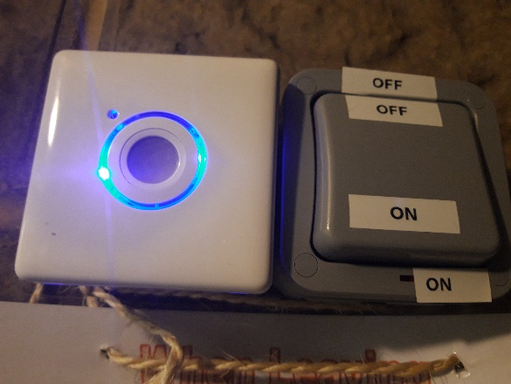
OFF

2) Press the BLUE illuminated button. This turns on the carpark lights for 5 minutes which will allow you to clear the car park and lock the gate.
BLUE BUTTON
The switch will FLASH RED when there is 1 minute to go. After a total of 5 minutes the lights will turn themselves off.
Pushing the illuminated switch only, will NOT turn off the car park lights and they will stay on all night to the annoyance of our neighbours.
If the lights are left on a £10 deduction will be made from your deposit.
Thank you for your cooperation with this.

Leaving Hall Check List
All windows closed

Hall
Kitchen
Cloak Room

Fire exit doors closed

Single door
Double door

Electrics off

Cooker
Lights
Hall
Kitchen
Hall way
Male Toilets
Female/accessible toilets
Cloak room
Car Park (see page 3)

Wipe surfaces

Kitchen
Hatch
Any tables used

Sweep Floor

Hall
Kitchen
Hall way
Male Toilets
Female/accessible toilets
Cloak room

Empty

Fridge
Rubbish (take home)
Recycling (take home)

Mop Floor

Kitchen
Male Toilets
Female/accessible toilets

